CN LAB 5
24k-0810
Sending Email from PC 0 to PC 1:
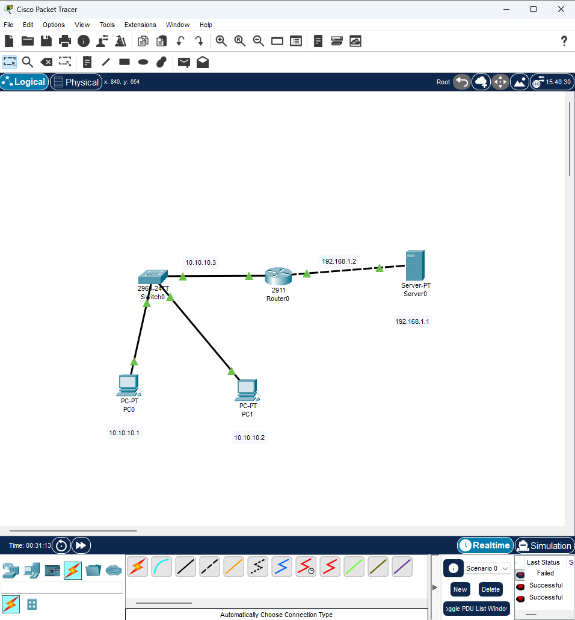
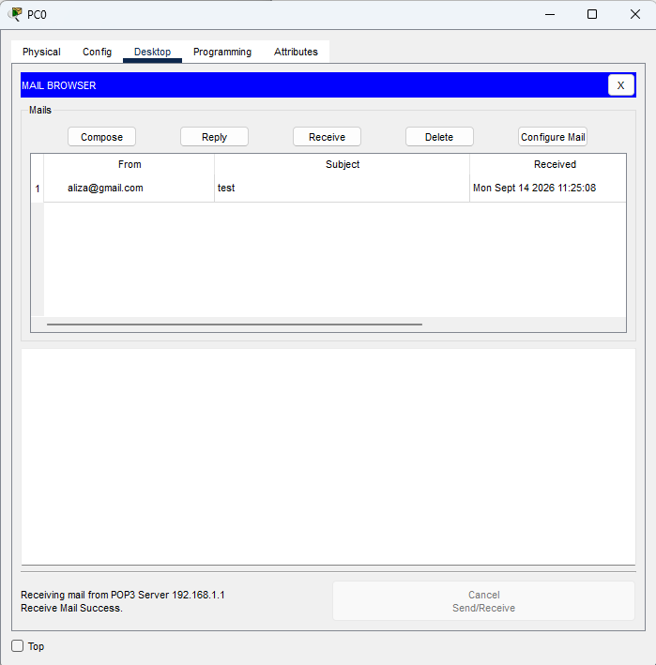
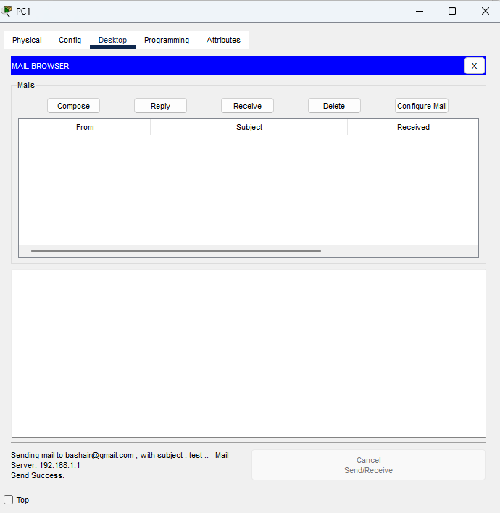

Putting notes.txt file in PC 0 and getting it in PC1
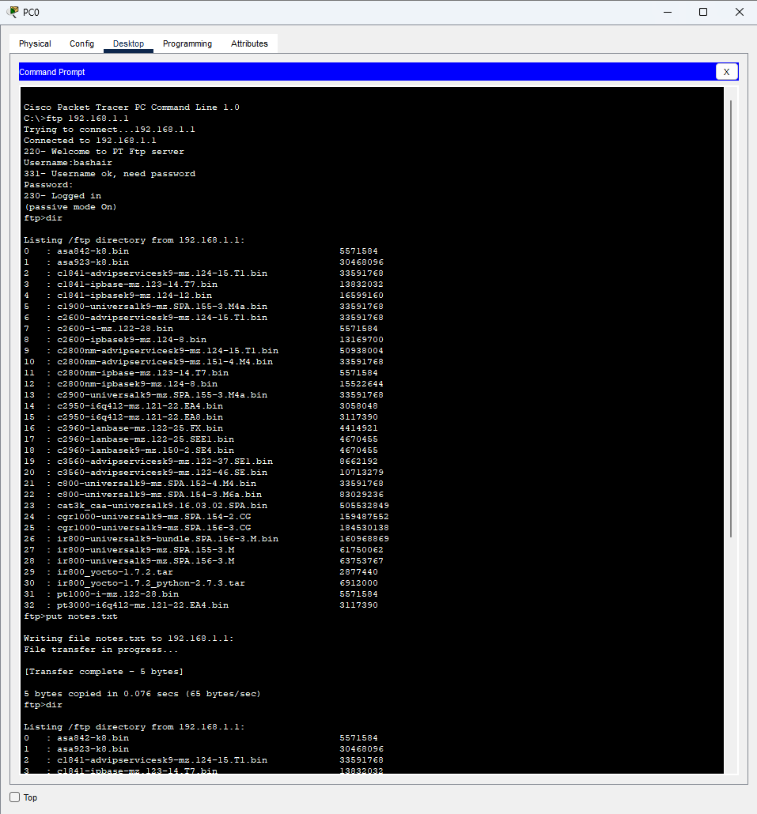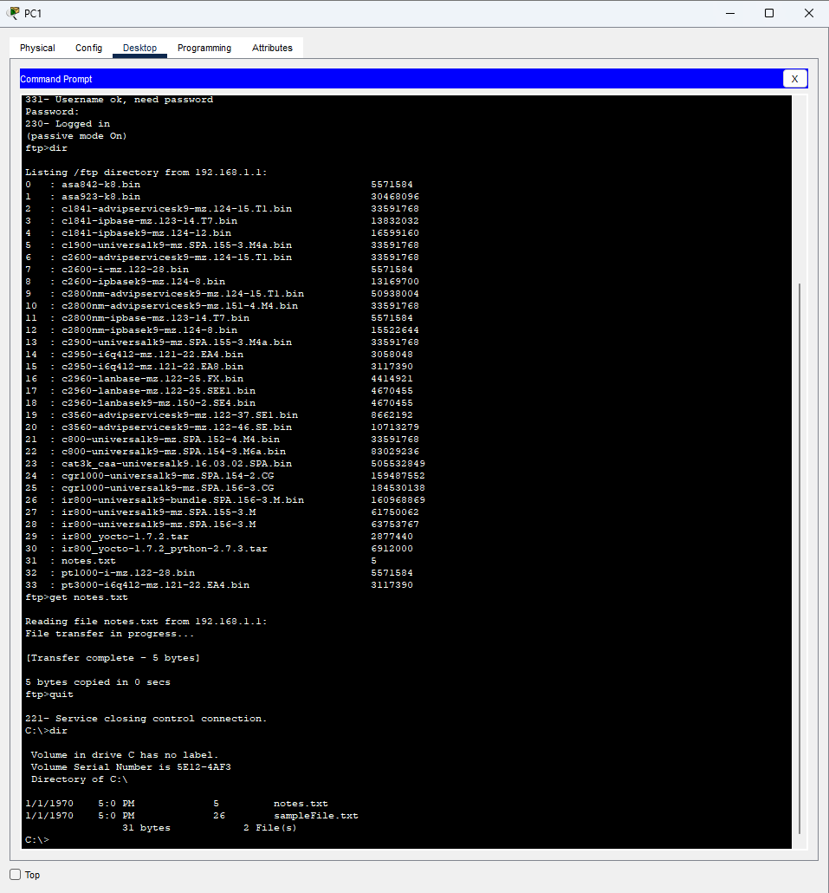
Objectives:
1. Configure email and FTP services and test their functionality.
2. Analyze SMTP, POP3, TCP, and FTP packets in Cisco Packet Tracer.
3. Capture and analyze HTTP login traffic using Wireshark.
4. Understand the security risks of plain HTTP and the use of HTTPS.
5. Understand SMTP, POP3, FTP modes, and TCP reliability.

SECTION 1:
Task 1:
● Question: Configure the existing network topology by adding a new PC with IP address
10.0.0.6/8. Add a user account on the Mail Server with username se and password 999.
Demonstrate sending an email from bba@fast.com to se@fast.com.
● Deliverable: Show the received email on PC and capture the PDU header info during the POP3
receive operation.
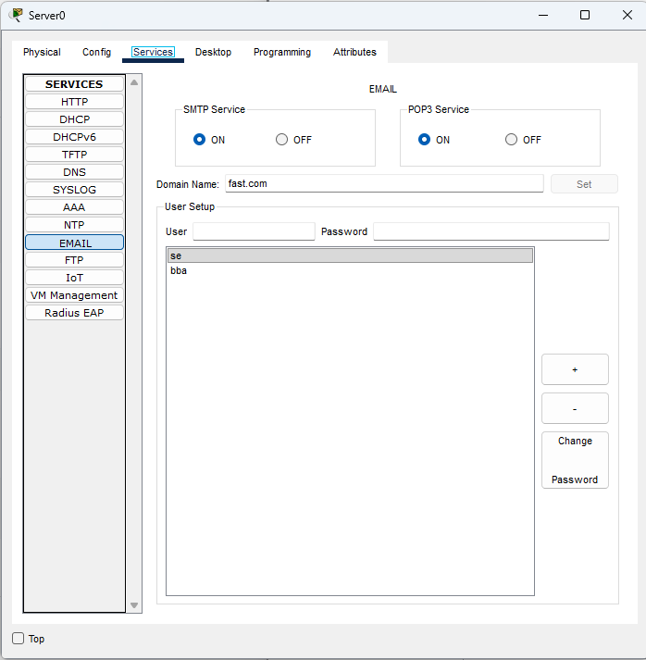
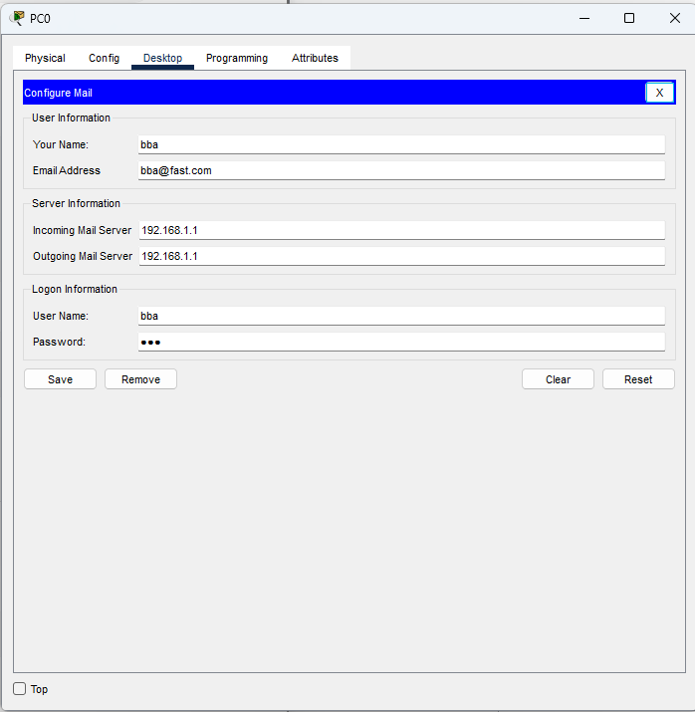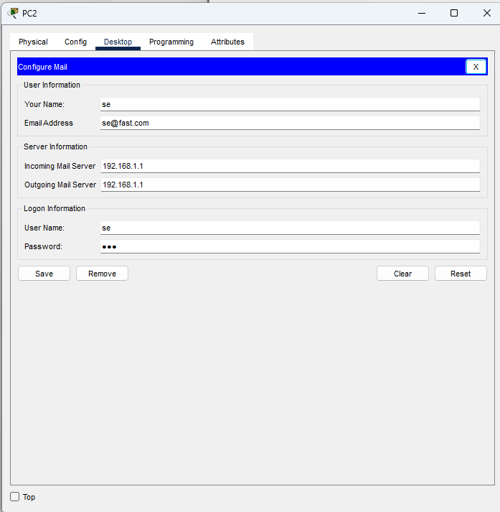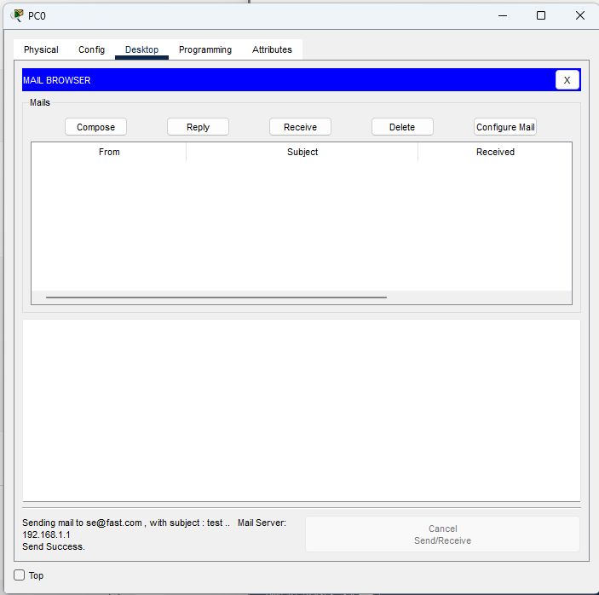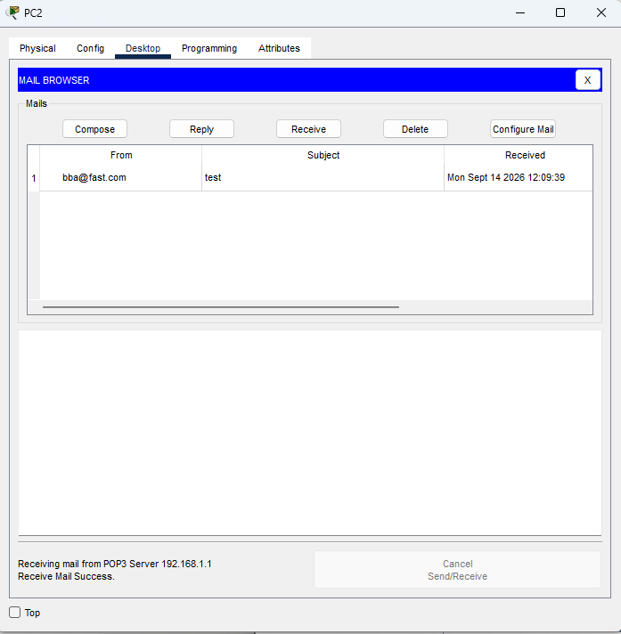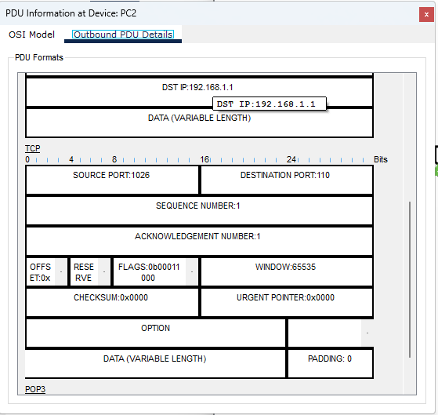
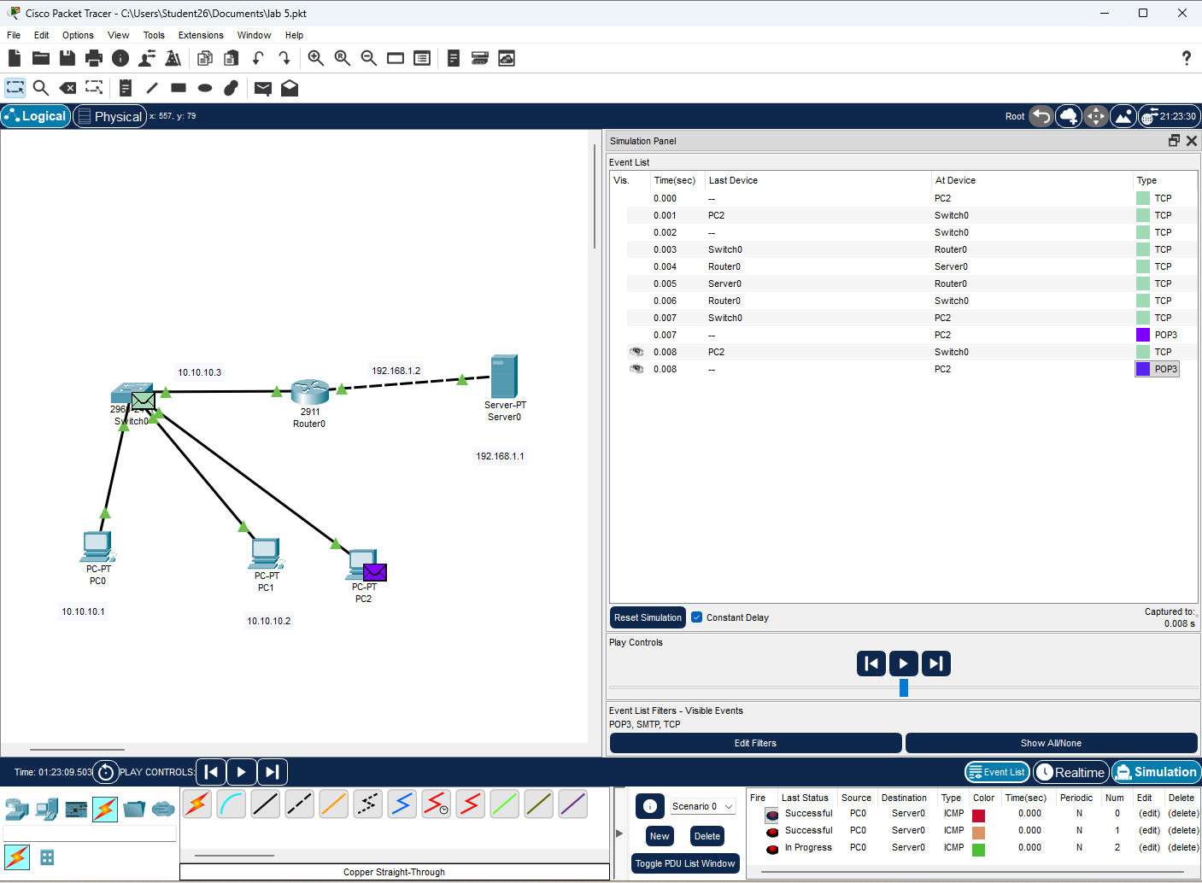

Task 2:
● Question: On the FTP Server, create two different user accounts:
1. User_Admin: Full permissions (Read, Write, Delete, Rename, List).
2. User_Guest: Restricted permissions (Read and List ONLY).
● Perform the following tests from the command prompt: a) Log in as User_Guest and attempt to
upload a file named report.txt using the put command. State the observed result and error
message.
b) Log in as User_Admin and upload report.txt. Then use the delete command to remove it from
the server.
● Deliverable: Screenshots of both command prompt sessions showing successful and denied
operations.
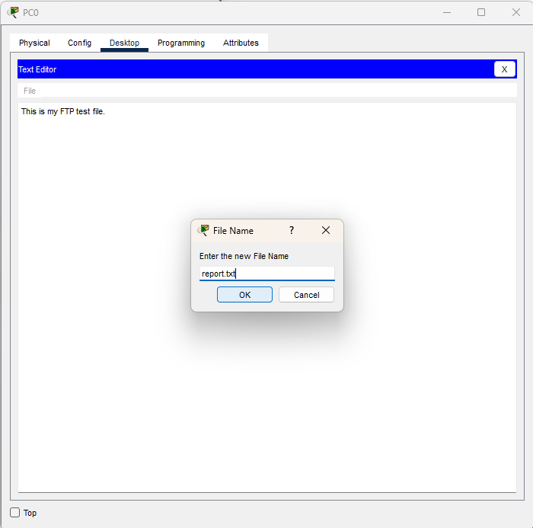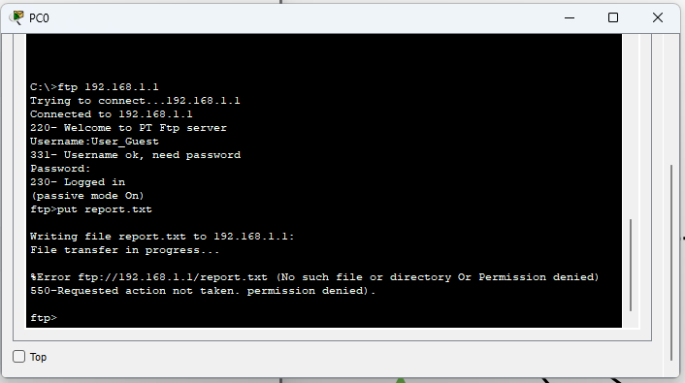
(b)
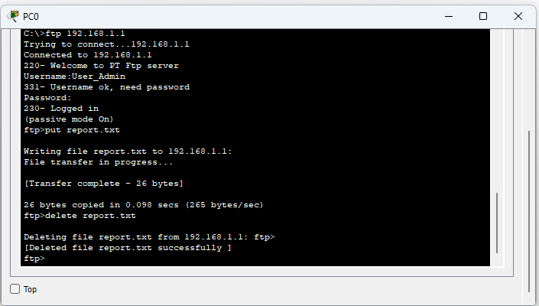

Task 3:
Question: Put Cisco Packet Tracer into Simulation Mode and filter only SMTP, POP3, and TCP events.
a) Compose and send an email. Identify the TCP Source and Destination Port numbers when the
client sends the email to the server.
b) Click Receiveon the recipient PC. Identify the Application Layer Protocol and Destination
Port used during this packet exchange.
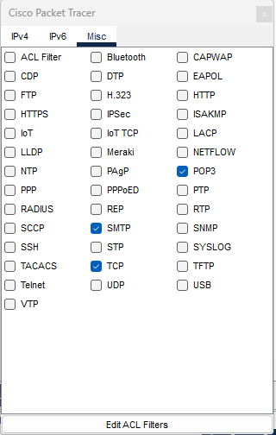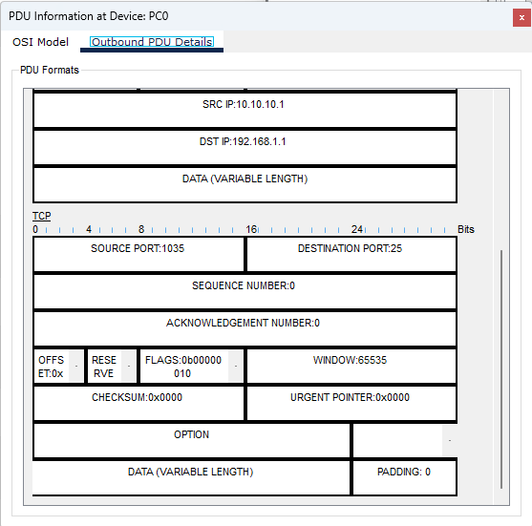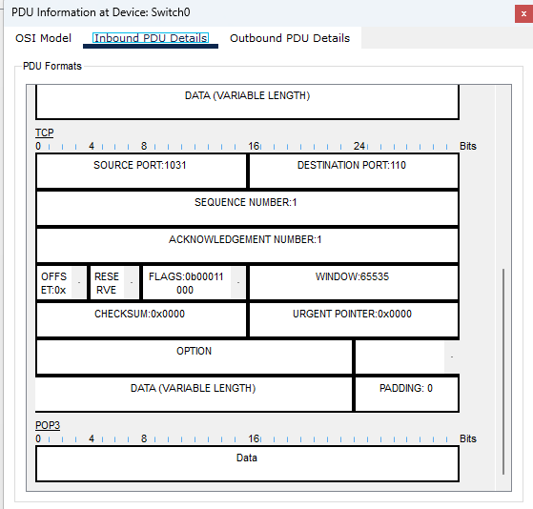
The TCP destination port used by SMTP is 25. The source port is an ephemeral port assigned by the client and it is 1035.
SECTION 2:
Question 1: Open Wireshark and start capturing traffic. Generate TCP traffic on your network and
analyze the TCP communication.
Part A: Apply the tcp filter and locate a TCP packet. Identify the following:
• Source Port
• Destination Port
• Sequence Number
• Acknowledgment Number
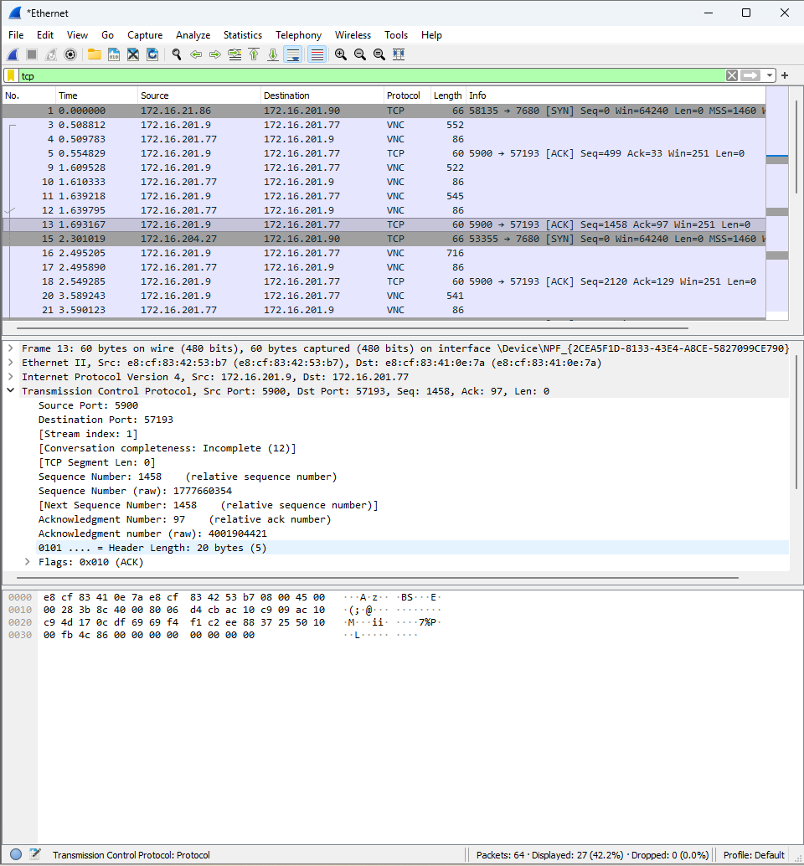
Part B: Expand the Transmission Control Protocol section of the selected packet. Identify the values of:
• Header Length
• Flags
• Window Size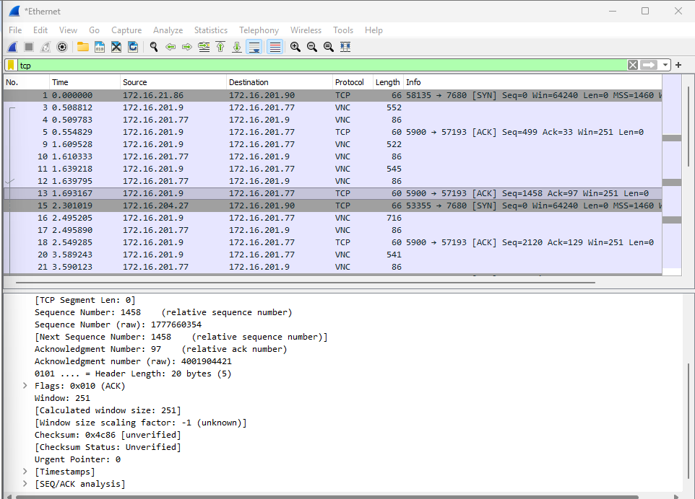
Part C: Locate the TCP packets involved in establishing a connection. Identify the three steps of the TCP
three-way handshake and state the TCP flags used in each step.
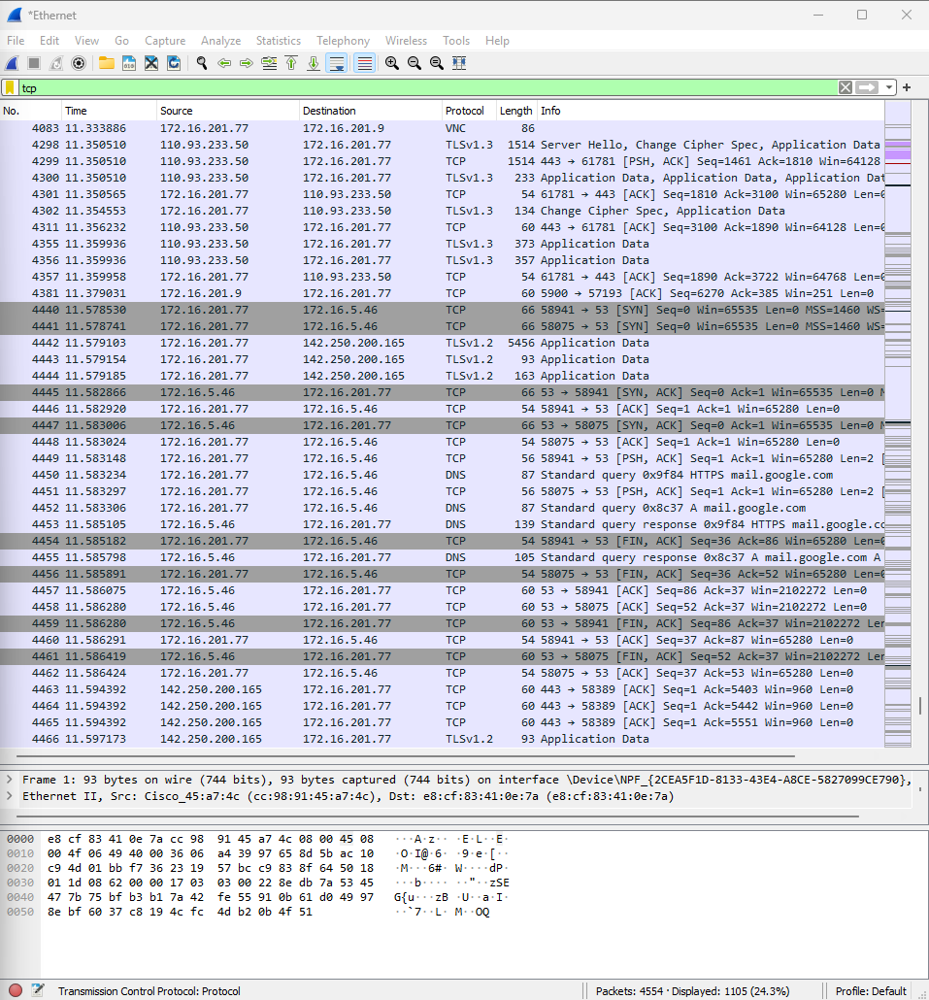
Part D: Explain why TCP uses a three-way handshake before data transmission. What is the purpose of
the SYN and ACK flags?
TCP uses a three-way handshake to establish a reliable connection before data transmission. It allows both devices to confirm that the other device is reachable and to synchronize their initial sequence numbers.

SYN: SYN (Synchronize) is used to initiate a TCP connection and synchronize sequence numbers.

ACK: ACK (Acknowledgment) confirms that a packet or sequence of data has been received.
SECTION 3:
1. Why do we need two different protocols (SMTP and POP3) for a complete email interaction?
Why can’t SMTP be used to read emails?

SMTP and POP3 perform different functions. SMTP is used to send and relay emails, while POP3 is used to retrieve emails from a mail server to the recipient's email client. SMTP cannot be used to read emails because SMTP is designed for sending and transferring messages, not for retrieving messages from a user's mailbox.
2. FTP is known as an out-of-band protocol. What does this mean, and which port numbers are
used for control and data connections in Active FTP?
TP is called an out-of-band protocol because it uses separate connections for control information and data transfer. The control connection carries commands such as login, upload, download, and delete, while the data connection carries the actual files.
3. In what scenario would Active FTP fail, requiring the client to switch to Passive Mode (PASV)?
Active FTP can fail when the client is behind a firewall or NAT that blocks incoming connections. In Active FTP, the server initiates the data connection toward the client. If this incoming connection is blocked, data transfer fails. Passive FTP (PASV) can be used because the client initiates the data connection.
4. Why do SMTP, POP3, and FTP all rely on TCP rather than UDP at the Transport Layer?
SMTP, POP3, and FTP use TCP because they require reliable and ordered delivery of data. TCP provides error detection, retransmission of lost packets, sequencing, flow control, and reliable delivery. UDP does not guarantee delivery or packet ordering, so it is not suitable for these applications.

